**WORKING WITH DATASET**

**UPLOADING THE DATASET**

|  |  |
| --- | --- |
| **TEAM ID** | PNT2022TMID08920 |
| **PROJECT NAME** | Corporate Employee Attrition Analysis |

**UPLOADING THE DATASET:**

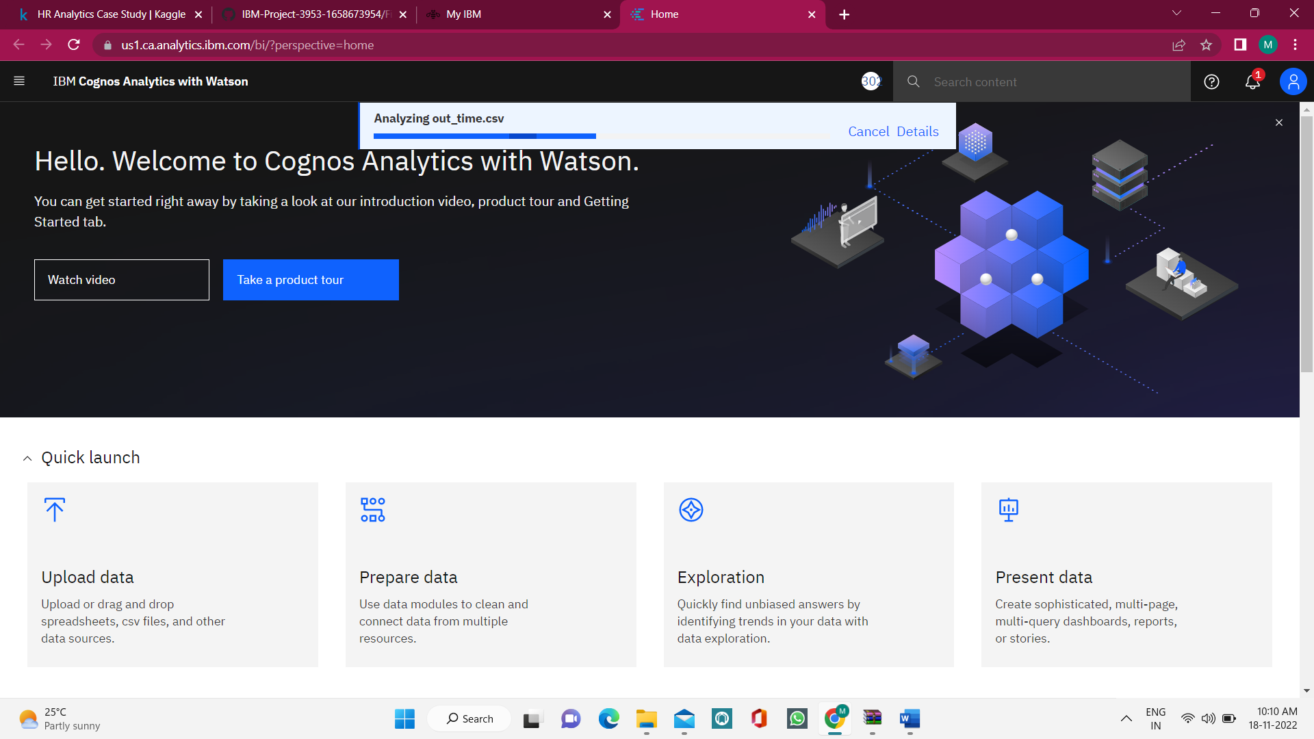Here, the dataset is loaded to content.